Detailed Class Design for the Address Book Example

Given below is a "three compartment" design for the classes appearing in the class diagram. This information was not included in that diagram due to size considerations; however, it could have been - in which case this document would have been unnecessary.

* Class AddressBook
* Class AddressBookApplication
* Class AddressBookController
* Class AddressBookGUI
* Class FileSystem
* Class Person
* (No detailed design is given for Comparator class Person.CompareByName)
* (No detailed design is given for Comparator class Person.CompareByZip)
* (No detailed design is given for utility class MultiInputPane)

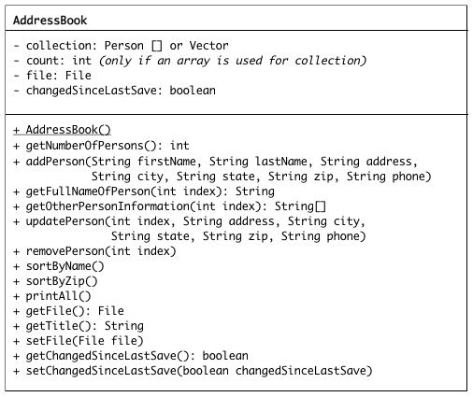

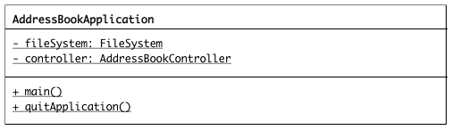

**The detailed design of class AddressBookController is left as an exercise to the student**

